- Welcome and Sign In: Please feel free to reach out to Debbie Bell debbiey.bell@ky.gov if you need a copy of the MAPP sign in sheet with present MAPP members.
- Announcements and Community Health Improvement Plan Updates:
- Debbie Bell, FCHD Health Education Coordinator welcomed everyone to the MAPP meeting. Everyone was encouraged to complete the Quality of Life Survey if you haven’t already done so. This can be completed online using the following: 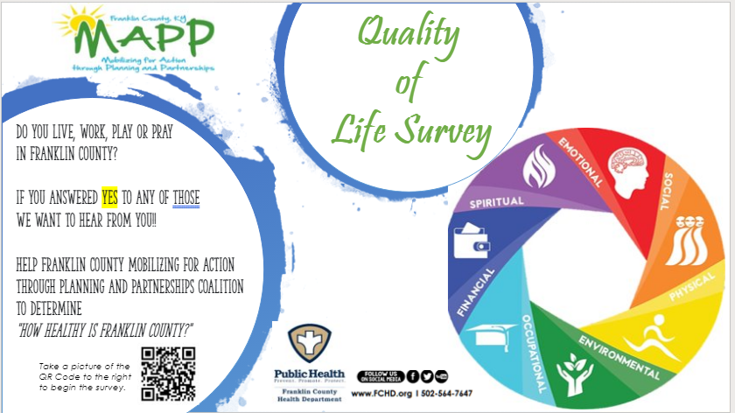
Or using this web link: https://www.surveymonkey.com/r/H3BZDCF The survey link was sent upon request to: The Chamber, Franklin Co Fire Department, Pam Tate, PFLAG, Good Shepherd Church
- MAPP partner Electronic Newsletter – Please have information you would like to share to the group to Debbie Bell at debbiey.bell@ky.gov no later the 20th of every month. Website links can be sent out and are welcome so that the file doesn’t get too big. The Newsletter will go out the first week of every month highlighting community partner events and tidbits for that month.
- Parking Lot – the parking lot in the back of the room is for any announcements, comments, concerns, etc. you have while at the meeting. If a sticky-note is placed on the parking lot an FCHD staff will take care of the request, comment or concern and share it with the group through the newsletter, email, etc.
- Are we connected – Please consider linking up with our MAPP coalition, if you haven’t already done so, by downloading the Franklin Co MAPP Community Health Assessment (CHA) and Community Health Improvement Plan (CHIP). Both are located at http://www.fchd.org/CommunityHealth/MAPPCoalition.aspx .
- Just Say Yes Debrief and Summary: (Charlie Kendell and Judy Mattingly) – provided a recap of Dr. Harvey Milkman’s visit to discuss implementing the Iceland Model for drug use prevention. Some of the results of the summit include: increased interest in the community; sense of hope; role in obtaining fresh local data. Stay tuned!
- Forces of Change Assessment: (Brittany Parker) This is an assessment that is designed to help answer the following questions:
  - What is occurring or might occur that affects the public’s health in Franklin Co?
  - What specific threats or opportunities are generated by these occurrences?
MAPP members were encouraged to work in groups on a brainstorming activity to address a series of questions that assist in identifying forces. They were then asked to write each identified forces on post it notes and were used to create an Affinity Diagram. The diagram was used to group forces under categories. The results will be available during the February 20th MAPP meeting and added to the Community Health Assessment.
- information or announcements. All information will be placed in the December edition of the MAPP e-newsletter.
- Meeting adjourned at 1:30 pm.
- Next Meeting:
Please make plans to come out and join us Thursday, February 20, 2020 at 12:00 pm at the Public Health Center, 851 East-West Connector.

THANK YOU FOR YOUR TIME AND PARTNERSHIP

