- Welcome and Sign In: Please feel free to reach out to Debbie Bell debbiey.bell@ky.gov if you need a copy of the MAPP sign in sheet with present MAPP members. Lunch was provided by the Franklin Co Health Department
- Announcements and Community Health Improvement Plan Updates:
- Debbie Bell, FCHD Health Education Coordinator welcomed everyone to the MAPP meeting. Members were updated on the progress of having individuals complete the Quality of Life Survey – at this time 612 surveys have been completed or 11% of our goal (5000 surveys completed). Everyone was encouraged to complete the Quality of Life Survey if you haven’t already done so. This can be completed online using the following: 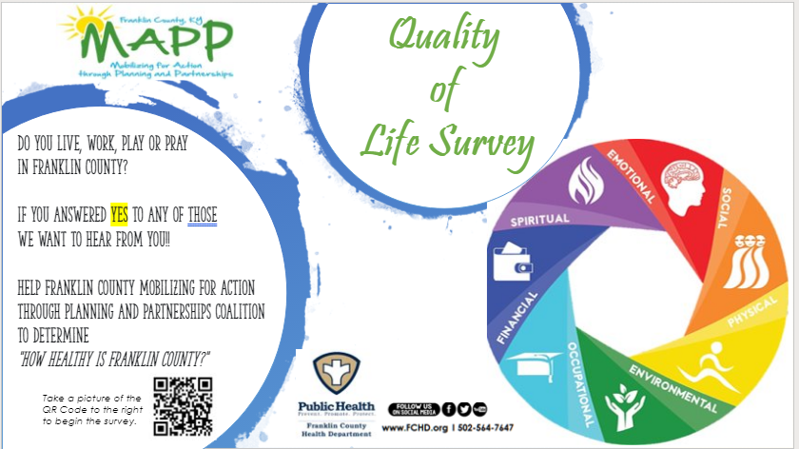
Or using this web link: https://www.surveymonkey.com/r/H3BZDCF - please share with your contacts in Frankfort/Franklin Co
- MAPP partner Electronic Newsletter – Please have information you would like to share to the group to Debbie Bell at debbiey.bell@ky.gov no later the 20th of every month. Website links can be sent out and are welcome so that the file doesn’t get too big. The Newsletter will go out the first week of every month highlighting community partner events and tidbits for that month.
- Parking Lot – the parking lot in the back of the room is for any announcements, comments, concerns, etc. you have while at the meeting. If a sticky-note is placed on the parking lot an FCHD staff will take care of the request, comment or concern and share it with the group through the newsletter, email, etc.
- Are we connected – Please consider linking up with our MAPP coalition, if you haven’t already done so, by downloading the Franklin Co MAPP Community Health Assessment (CHA) and Community Health Improvement Plan (CHIP). Both are located at http://www.fchd.org/CommunityHealth/MAPPCoalition.aspx .
- Adverse Childhood Experiences (ACES) Presentation– provided by Vivian Lasley-Bibbs, MPH, Acting Branch Manager and Epidemiologist; Office of Health Equity; Kentucky Department for Public Health.

- MAPP members were encouraged to pick up a flyer and/or stickers for their planners containing the upcoming MAPP quarterly meeting dates.
- information or announcements. All information will be placed in the September edition of the MAPP e-newsletter.
- Meeting adjourned at 1:30 pm.
- Next Meeting:
Please make plans to come out and join us Thursday, November 21, 2019 at 12:00 pm at the Public Health Center, 851 East-West Connector.

THANK YOU FOR YOUR TIME AND PARTNERSHIP

